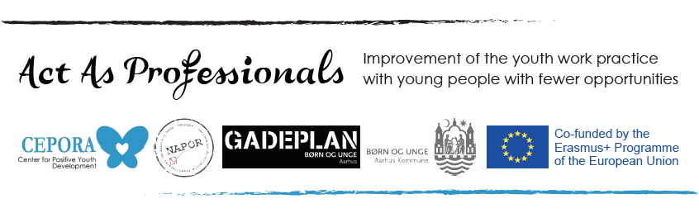

Application form

When filling in this form be sure to add all relevant information that would show how your expertise and experience match with requirements stated in Call for participants.
A.1. CV
I Personal details
Name and surname
Address
Phone
e-mail
Date and place of birth
Organization/Institution
II Relevant work experience and volunteer engagement
1. Date (from – to):
Employer/position
Main responsibilities and achievements
2. Date (from – to):
Employer/position
Main responsibilities and achievements
3. Date (from – to):
Employer/position
Main responsibilities and achievements
Other relevant competences
Foreign language competence
Language | Reading | Writing | Conversation
Please add more rows if needed
A.2. Motivation
Please describe your motivation for participating in this training?
In what way you will contribute to the training?
How do you plan to transfer gained knowledge and skills from the training to NAPOR member organisations?

A.3. Confirmation
(please check the boxes)
Please confirm your participation in online training from 14th to 17th December, 2020. each day from 16:00-19:00h (including breaks)

Application form, together with confirmation from the NAPOR member organization has to be send until 10th December 2020. Confirmation about applicants’ active engagement in NAPOR member organization has to be submitted on the organization's memorandum, with the signature and seal of the responsible person. The confirmation shall indicate the time frame in which the person is active in the organization, as well as the position and the list of responsibilities.

